CAPSTONE PROJECT

Project 2:

1. Create a BASH script = azurestorage.sh
2. Make script executable = chmod +x azurestorage.sh
3. Deploy script = ./azurestorage.sh deploy

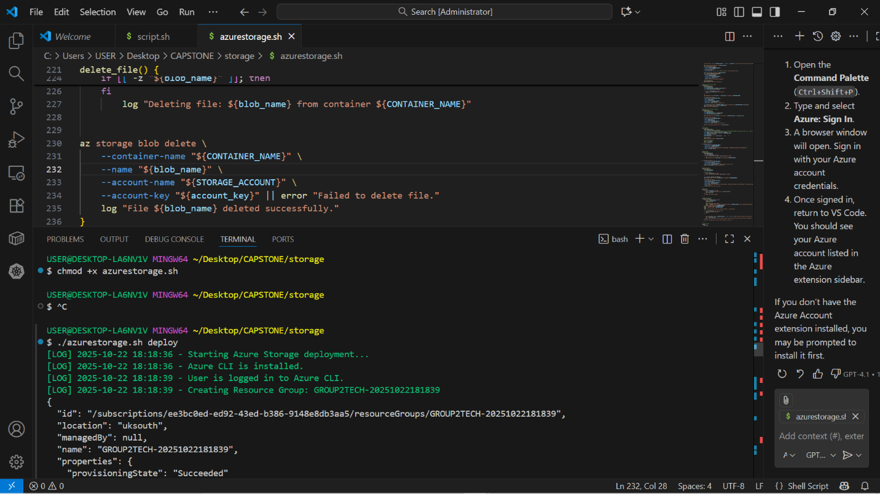

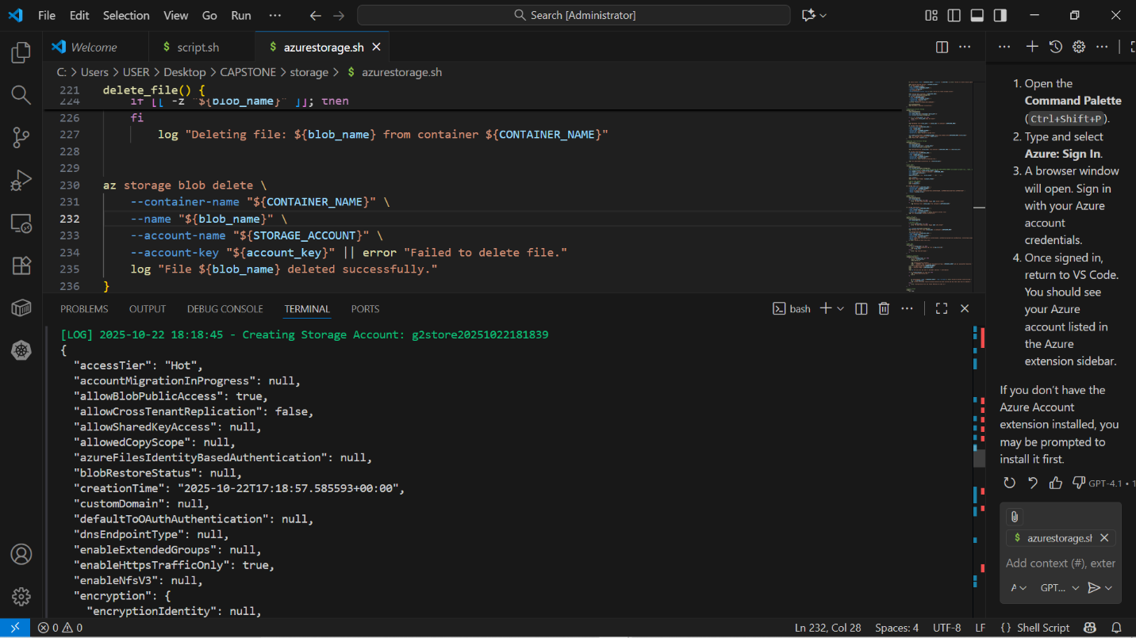

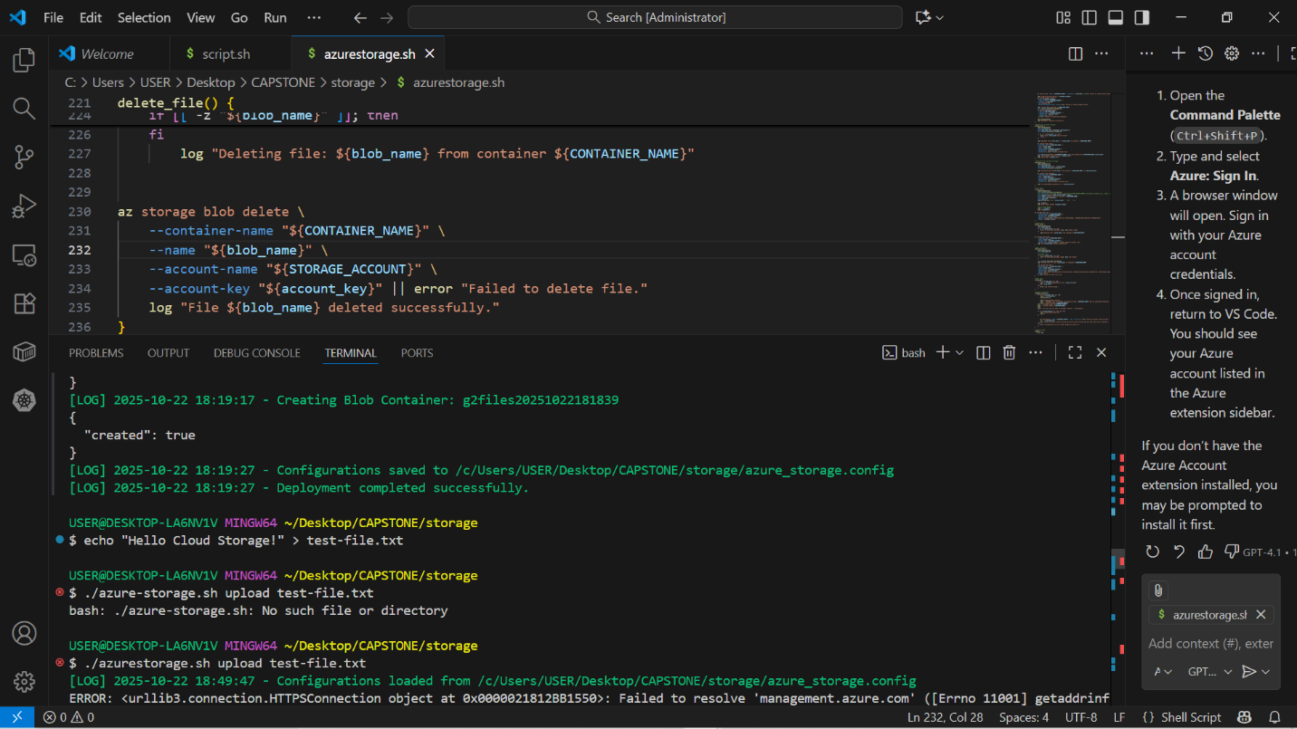

DEPLOYMENT SUCCESSFUL

1. Create a mockup file = echo “Hello Cloud Storage!” > test-file.txt
2. Upload a file = ./azurestorage.sh upload test-file.txt

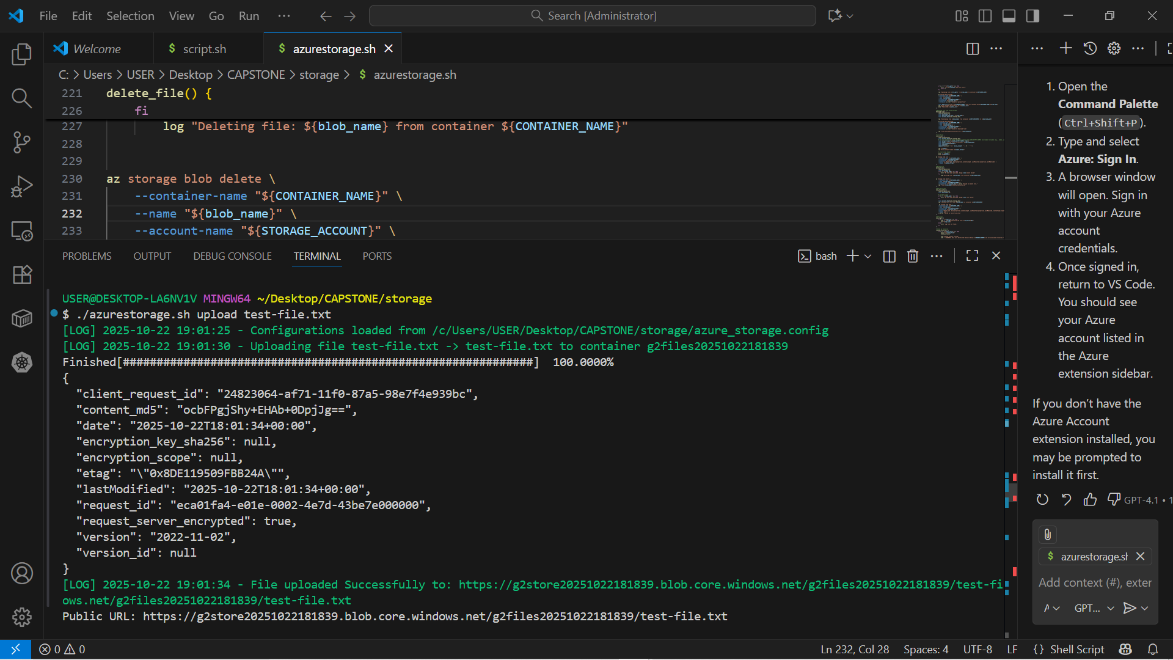

1. A public URL will be generated; Public URL: https://g2store20251022181839.blob.core.windows.net/g2files20251022181839/test-file.txt
2. List files in your azure storage container = ./azurestorage.sh list
3. Download file from your azure storage container = ./azurestorage.sh download test-file.txt downloaded-file.txt

Note: downloaded-file.txt is what the file will be renamed as in your local repo

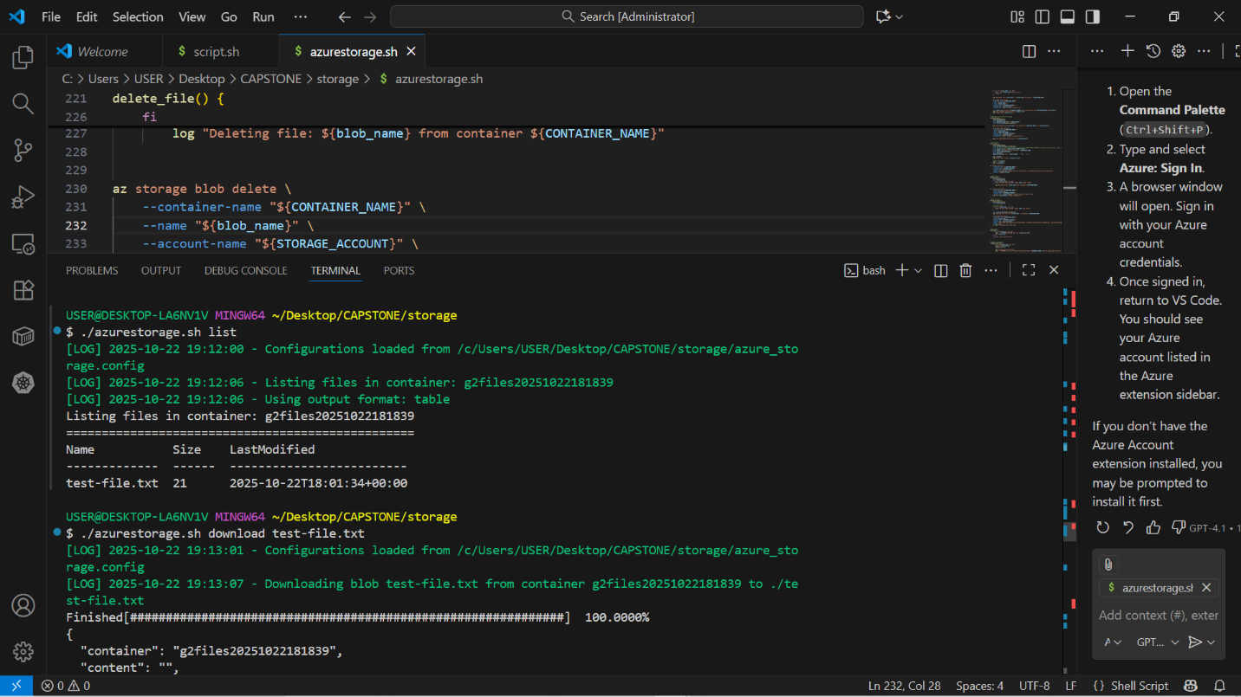

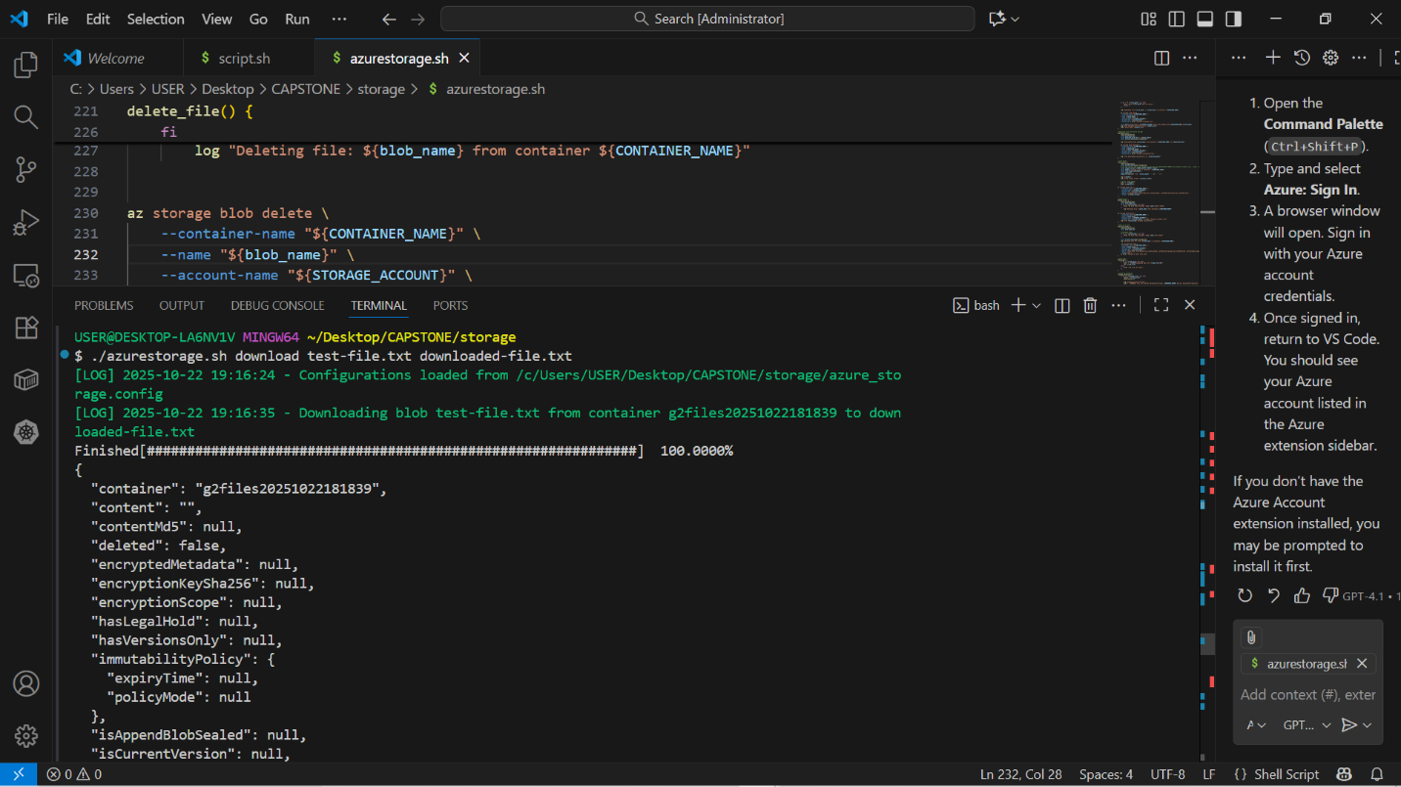

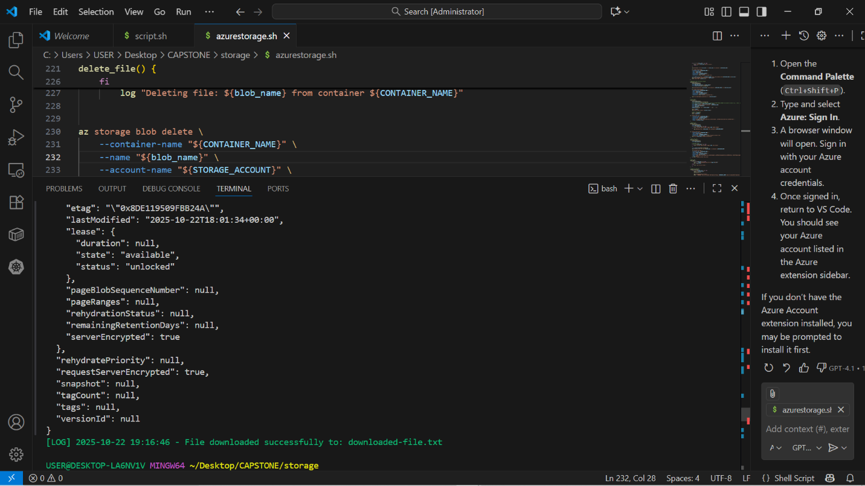

1. 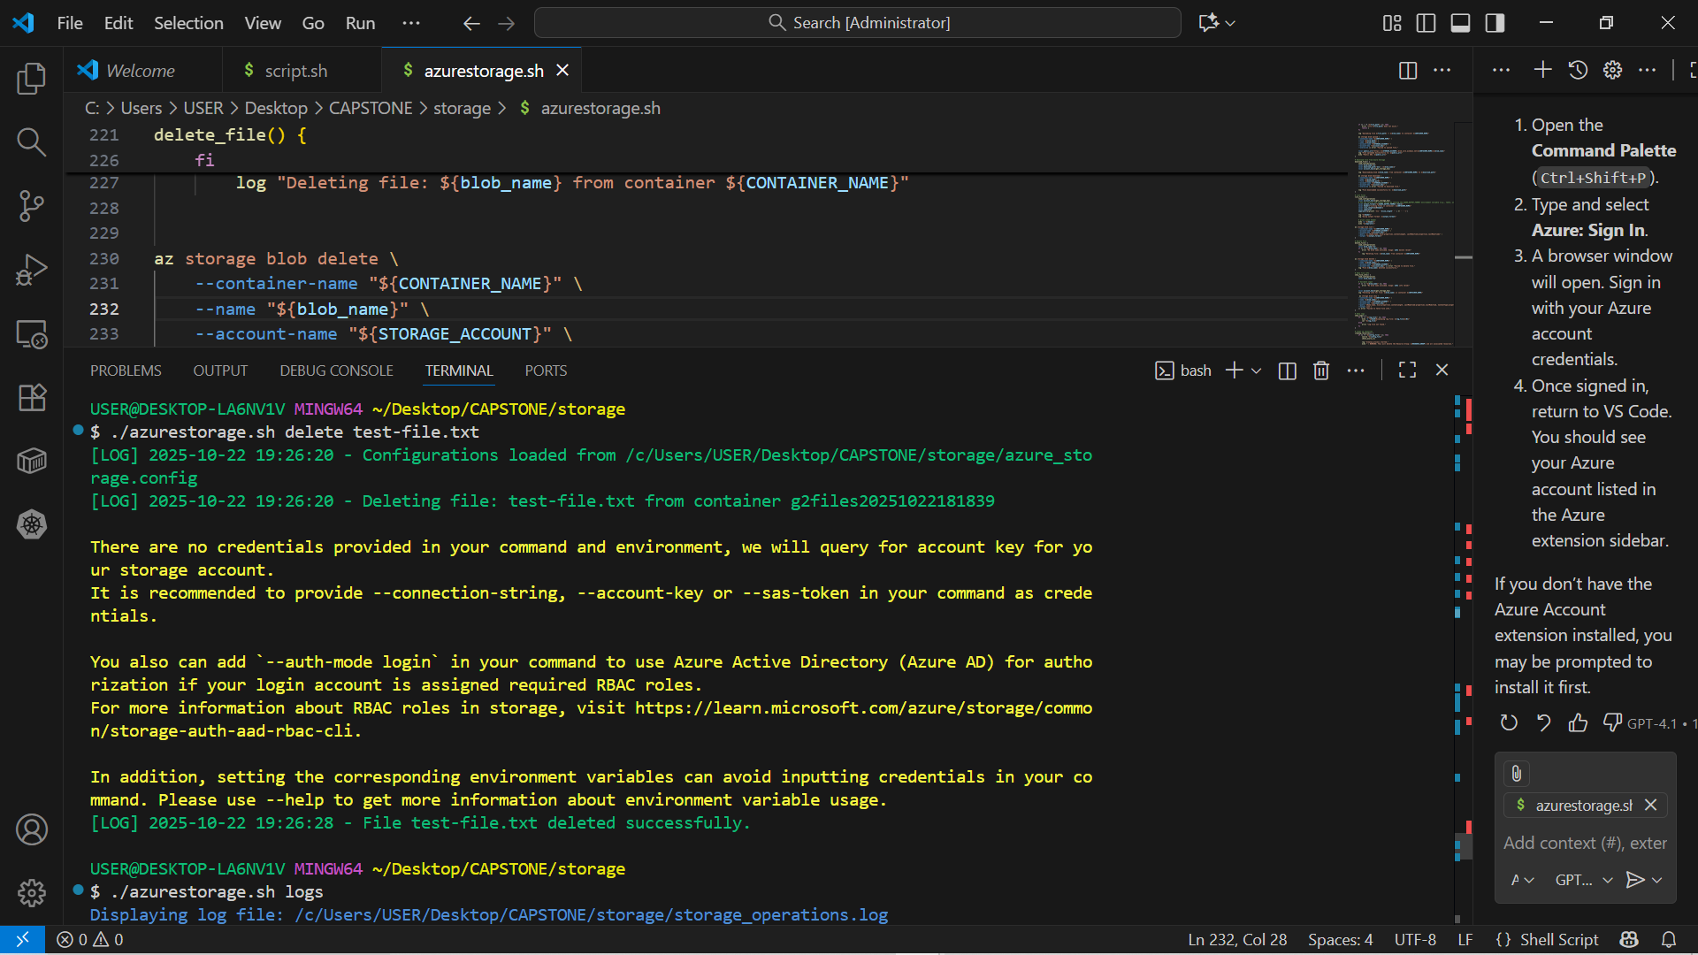Delete File = ./azurestorage.sh delete test-file.txt
2. Get the log of your operations = ./azurestorage.sh logs

